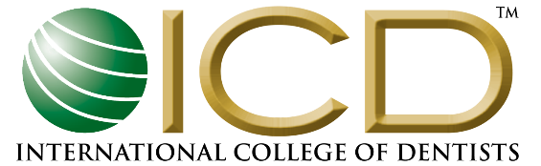
USA SECTION
610 PROFESSIONAL DRIVE, SUITE 201 GAITHERSBURG, MD 20879
PHONE: (301) 251-8861 FAX: (240) 224-7359 WWW.USA-ICD.ORG

2024 ICD USA SECTION STUDENT INITIATIVES
PARTICIPATION APPLICATION

BETTIE R. McKAIG STUDENT EXPERIENCE PROGRAM

Please include the following information using a separate page for each student trip.
- Name and address of USA dental school requesting grant
- Contact person’s name/e-mail/phone number
- Trip Name
- Type of Trip (Mission or Exchange)
- Location (NOTE: Domestic humanitarian trips/projects are now eligible for grants)
- Inclusive dates or duration
- Number of USA students (mission trips) or number of international students (exchanges)
- Faculty Involvement (Do they travel with students?)
- Where do students go? (School, orphanage, village, etc.)
- General itinerary (Do USA students study with host students? Do they provide homecare instructions to children/adults? Do they deliver clinical dental care? Do they observe or participate in cultural activities? Similar questions for international students who visit the USA)
- Are ICD Fellows involved with this trip?
- Estimated total cost per student
- Other sources of income (student fundraising, local ICD chapters, others)
- What is the most valuable benefit to the participating students?
- Please include any additional pertinent information about this trip.

Please submit your application to Dr. Elaine Wagner, ICD USA Section Executive Director, ewagner.regusa@usa-icd.org.

APPLICATION DEADLINE:
February 29th for the 2024 Student Experience Program.

Submitted by: _________________________________________________
Date: ________________________________________________________
NOTE: To remain eligible for this program next year we require you to submit a trip report (ONE report PER TRIP) to ICD USA highlighting the activities and the impact of the students’ international experience. Reports are due by December 1st of the awarded grant year. Please submit your trip reports to kylie@usa-icd.org.

